Title of Paper
^{1,2}First Author, ¹Next Author & ²Last Author
¹Author Address
²Author Address
Contact Person:
Contact person’s name
Address
Phone, email, homepage

Abstract. Use 10 pt Times font for body of the text with one spacing between lines, and 12 pt spacing for the next heading. Left and right indent 0.5 cm. Maximum length 200 words.
Keywords: use 10 pt; lower case; italic; Times; write alphabetically in 5-10 words.

Introduction
The section title use 12 pt, bold, Times, title case with 6 pt spacing to the body text. Use 11 pt Times for body of the text with one spacing between lines, 12 pt spacing between paragraph and 18 pt spacing for the next heading. To set the style, simply use this template and follow the instructions on section 2.

Style and Formatting
This template already set the style and formatting for the paper, so you can use those styles by typing the style name on the style box as shown in the figure below:
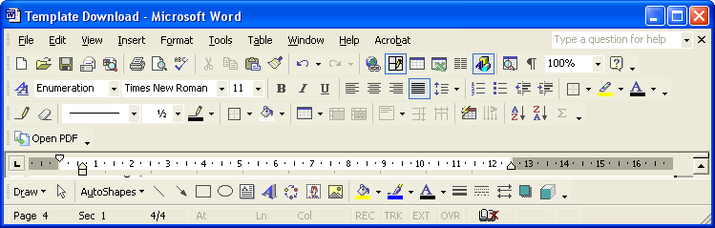
The styles used in this paper are:
- Title, for paper’s title
- Author, for author’s name
- Address, for author’s address
- Abstract, for abstract
- Heading 1, for section title
- Heading 2, for sub section title
- Heading 3, 4, 5, 6, 7, 8, 9 for the next sub … sub-section title
- Text, for body text
- Equation and Enumeration
- Figure (or Gambar), for figure caption
- Table (or Tabel), for table caption
- Reference, for references
- Acknowledge, for References and Acknowledge header

Mathematical Formulation
Equation should be type with indent 1.27 pt, and numbered consecutively starting with (1) set flush right.
To set the style, type Equation in the style box. But this style only set the tab stop position. To put the equation on the right place just press tab button one time. And to type the equation number, press tab button once again from the right side of the equation.
(1)

Section and Sub-section Title
Just type Heading 1 for section title, Heading 2 for sub section title, and Heading 3 for sub sub-section title. The number will set automatically.

Figures and Tables
All figures and tables should be centered and numbered consecutively.
FIGURE

- Type Figure in style box. The caption should be typed in lower case. Choose center if the caption fit on one line.
- Summary of Physical Parameters
No | Segments | Length  (km) | Elevation  (meter)
1 | A-B | 25 | 30
2 | B-C | 75.15 | 10
3 | C-D | 44.75 | 50
4 | D-E | 72.5 | 10
5 | E-F | 21.25 | 10

Length
Maximum length of article is 20 pages including all pictures, tables, nomenclature, references, etc.

Acknowledgement
You can type your acknowledgement here, including the fund source. (“Parts of this research is funded by Riset ITB No. …. “)

Nomenclature (if necessary)
List the nomenclature in alphabetical order. List Roman letters followed by Greek symbols followed by subscript and superscripts.
A | = | Amplitude
C_{d} | = | drag coefficient
f_{e} | = | linearization coefficient
K_{i} | = | modification factor
γ | = | wave number
ψ | = | Complex wave number

References
Within the text, references should be cited by giving last name of the author(s) and the year of the publication as:
Whitson (1995) has studied ….
...... the resulting equation is (Becker, 1998; Graf, 1999 and Morris et. al, 1996)
(2) (2)
Note that in the case of three or more authors, only the last name of the first author is cited and the others are denoted by et al. The same rule is also hold for header title in even page.
Use the same typeface as the body of the text for the references, or just type Reference in style box. Examples are:
- Sutasurya, L. A., Title of paper, Name of Journal 5, 1-5 (1998).
- Sutasurya, L. A., Handojo, A. & Riyanto, B., Title of paper, Name of Journal 8, 20-25 (1999).
- Sutasurya, L. A., Handojo, A. & Riyanto, B., Title of book, ed. 2, Publisher (1997).
- Suharto (ed), Title of paper, Name of Proc., Publisher (1998).
- Name of the author(s) (if available), Title of paper (if available), Organization, website address, (1 April 1999).

Appendix

Manuscript Content
The contents of the paper should be in the following order:
- Title of Paper
- Author names and affiliation
- Abstract
- Body of the text (Introduction ………. Conclusion)
- Acknowledgements
- Nomenclature
- References
- Appendix

Three hard copies and one soft copy of the article should be sent to LPPM ITB. Soft copy can be in form of a CD or can be emailed to qa@lppm.itb.ac.id. Article should be written on one side of good quality of A4 papers.
.

For typing footnote, simply choose Insert Footnote on the menu bar, it numbered automatically.

