Pameran Hasil Penelitian
Program Riset ITB dan Program Hibah DIKTI DIPA ITB 2010
Aula Timur ITB, 17-18 Februari 2011

Jadwal Acara
Kamis  17 Februari 2010  Jum’at  18 Februari 2010 | 08.00 – 13.00  13.00 – 13.15  13.15 – 15.00  15.00 - 16.30  08.00 – 13.00  13.00 – 15.00  15.00 - 15.15  15.15 – 15.30  15.30 – 16.00 | Pameran Hasil Penelitian  Pembukaan oleh WRRI (Dr. Wawan Gunawan A. Kadir,MS.)  Poster Session kegiatan penelitian dari:  FMIPA, SF, SITH, FTI  Hiburan  Pameran Hasil Penelitian  Poster Session kegiatan penelitian dari:  FITB, FSRD, FTMD, FTSL, FTTM, SAPPK, SBM, STEI  Pengumuman Poster Award  Penutupan  Hiburan

Ketentuan Poster
- Ukuran Poster (PIlih salah satu)
  - Potrait: 841 × 1189 mm
  - Landscape: 900x630 mm
- Poster harus memuat content sebagai berikut:
  - Logo ITB
  - Judul penelitian
  - Periode Penelitian
  - Pelaksana (Ketua dan Anggota Tim Peneliti)
  - Deskripsi singkat (Latar belakang permasalahan, metodologi, dan lain - lain )
  - Hasil Penelitian
  - Keluaran Penelitian (Judul Paper, foto produk, dan lain – lain)
  - Acknowledgement (keterangan sumber pendanaan)
- Template dan contoh poster dapat dilihat di website LPPM (www.lppm.itb.ac.id)
- LPPM ITB menyediakan hadiah menarik untuk kategori:
  - Poster dengan Desain Terbaik
  - Poster dengan Content Terbaik
  - Poster Favorit Pilihan Pengunjung
- Kriteria Penilaian
  - Kualitas Isi Poster
  - Kejelasan Penyampaian Informasi
  - Estetika
- Pengumuman pemenang akan disampaikan di akhir pelaksanaan kegiatan Seminar

Pemasangan Poster
- Tim Peneliti diberikan kesempatan untuk memasang poster pada tempat yang telah disediakan mulai hari Rabu, 16 Februari 2011 jam 15.00.
- Kegiatan pameran poster akan dimulai pada hari Kamis dan Jum’at 17-18 Februari 2011 mulai pukul 08.00 sampai dengan pukul 16.30
- Tim Peneliti dimohon untuk hadir pada kegiatan poster session sesuai dengan jadwal yang telah ditentukan.
- Poster yang telah dipamerkan dapat dibereskan kembali mulai hari Jum’at 18 Februari 2011 pukul 16.30

Scientific Posters: Tips, Significance, Design, Templates & Presentation*

Tips
- Know the audience
- Be focused and know the point you want to get across
- Provide a brief, clearly stated background and walk the audience through the content of the poster by interpreting all results
- Poster design and presentation:
  - Minimize words
  - Use graphs, charts, table as a tool for communicating ideas
  - Make it colorful
  - Be sure the text is in large font
  - Be sure the contents have a logical flow
  - Layout and headings must be visually stimulating
  - Be organized: the design of the poster and the style of delivery must be organized in order to be affective.
  - Practice presenting your poster and prepare a brief script (DO NOT READ OFF OF FLASH CARDS)
  - Have a postcard summary of your poster for people to take with them

Significance
A poster is like an exhibit at a museum. It is an excellent means of communicating scientific work because it is a pictorial representation that is more visual than any other form of presentation. A poster also allows the researcher to associate with other presenters and, at the same time, be able to talk directly with the audience. For these reasons, a poster should be visually stimulating with minimal words. It should a concise, organized summary that is clearly written with few words in large text.

Design
When designing a poster it is important to keep two things in mind: the scientific method and the audience. The scientific method is important because it directs the content of the poster. A brief background should be clearly stated and results should be interpreted for the audience.

Presentation
Unlike presenting scientific work through a paper in which the researcher is glued to a computer for days, presenting a poster is quite fun. It is the only chance for the scientist to talk to the audience. For this reason, it is important to know the message that you want to get across and be able to deliver it successfully. Simple, clear language and a good poster design are keys to a successful poster presentation.

*Dikutip dari Stanford School of Medicine (http://ppop.stanford.edu/posters.html)

Template Poster Landscape
(dapat diperoleh melalui http://www.lppm.itb.ac.id/?page_id=1789)

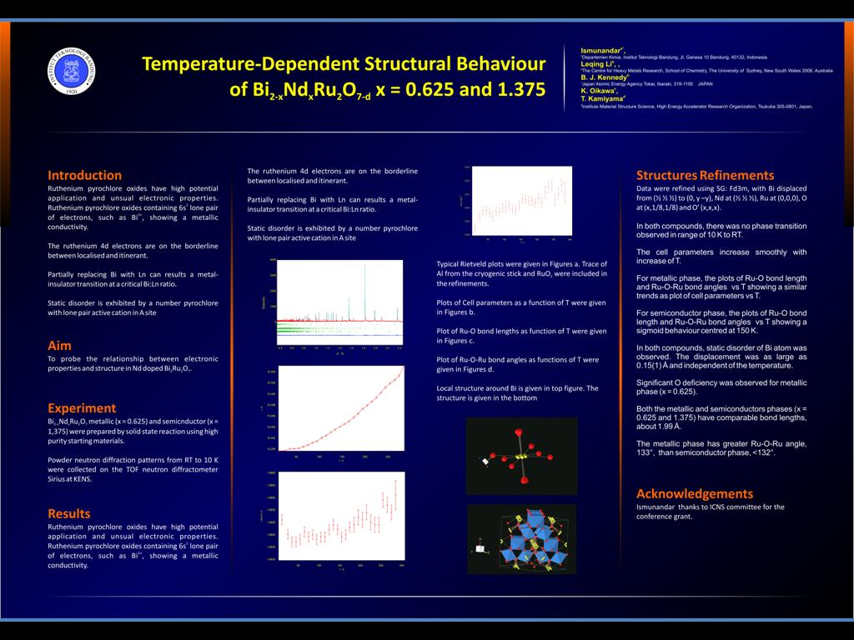 | 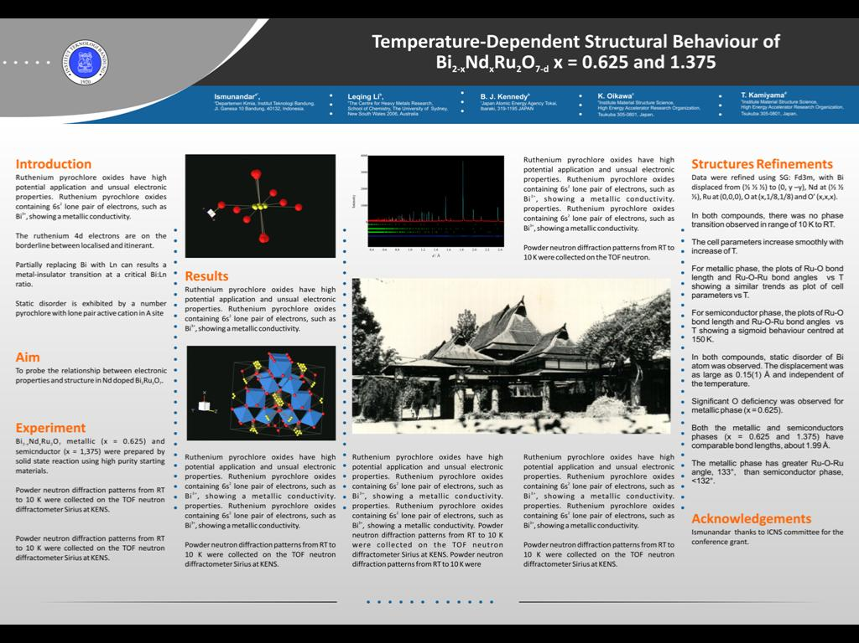
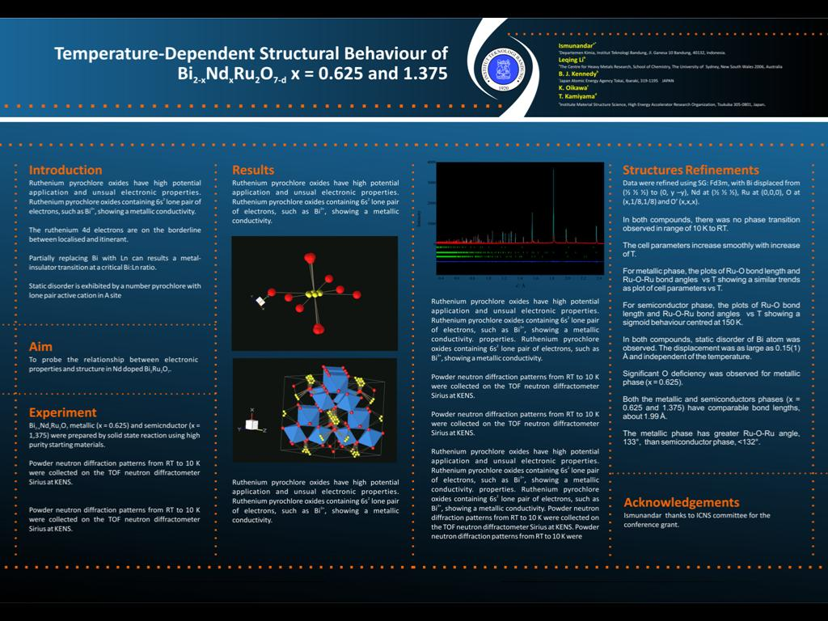

Template Poster Potrait
(dapat diperoleh melalui http://www.lppm.itb.ac.id/?page_id=1789)

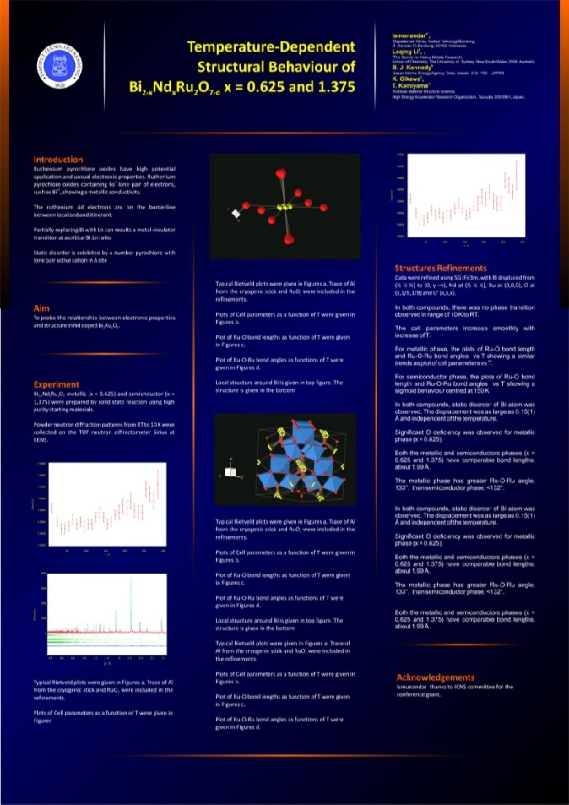 | 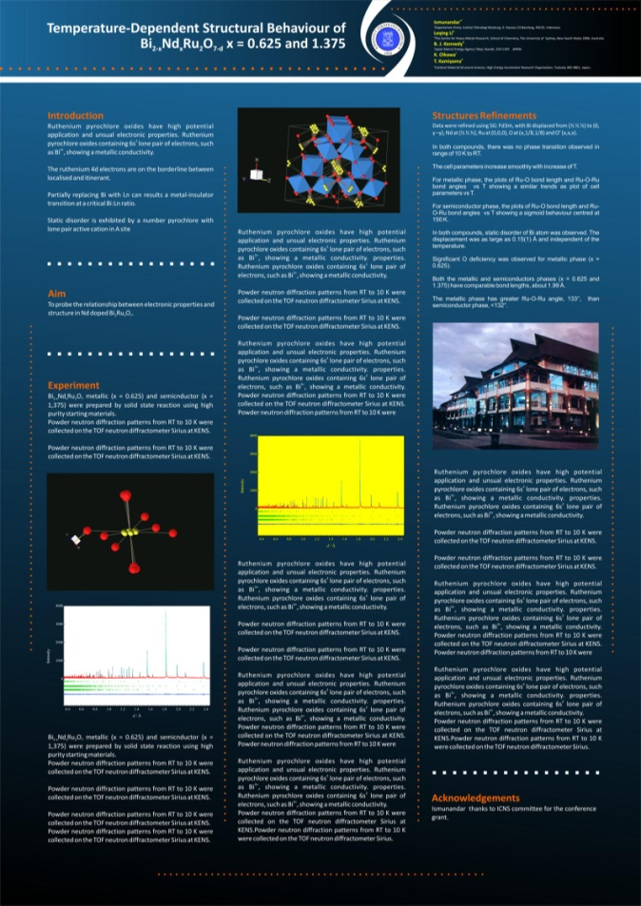
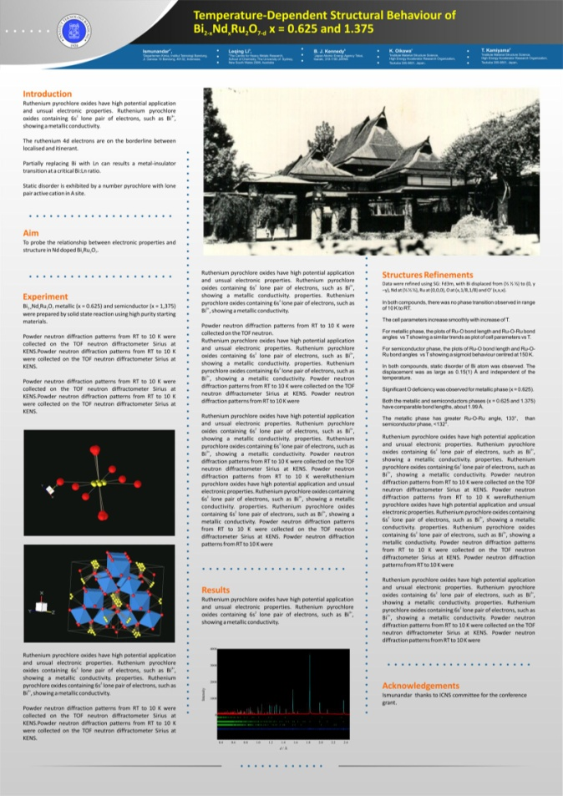 | 